
34, VISHALA ESTATE, S.P.RING ROAD,OPP.ODHAV TO NIKOL ROAD, NIKOL, Ahmedabad, Gujarat, 382350
GST NO:-:24ARDPD2565K1ZX

info@torqpackagingsolution.com
www.torqpackagingsolution.com

To.

Sub: - Semi automatic carbonated soft drink filling machine setup

Dear Sir,
Many thanks for your valuable inquiry of above subject. TORQ PACKAGING Solutions Is engage in making preliminary Bottle Packaging machines like bottle filling, capping, labeling, Automation, etc.… in Ahmedabad, we are having dedicated team for manufacturing, customized machine development, Sales, servicing and back office.

Thanks & Regards
Hardev Joshi
+91 95582 53251

Dear Sir,

We confirm the detailed discussion you had with undersigned, regarding your requirement of Semi Automatic Carbonated Soft Drink Filling WITH Auto capping machine Fully Setup(20 TO 25 bpm)
In this connection, we have pleasure to submit the Performa Quotation for the same.

PROFORMA QUOTATION

Sr.  No. | Description |  | Qty. | Amount  (Rs.)
1 | Semi-Automatic Carbonated Soft Drink Filling Machine and capping Machine |  | 1 Set | 5,80,000/-
2 | 8 Fit External Jambo Carbonator |  | 1 Set | 1,50,000/-
3 | Flavor Mixer Tank (200 Liter) |  | 1 Set | 50,000/-
(capping extra change part not included) Total |  |  |  | 6,50,000/-
18 % GST |  |  |  | 1,17,000/-
Total |  |  |  | 7,67,000/-
50 % Advance ,50% Before Delivery

- Semi Autometic Carbonated soft Drink Filling Machine Description
Semi autometic carbonated filling machine works on gravity principle with diving nozzles.
The unit is made compact, versatile and enclosed in stainless steel elegantly matt finish body, consists of S.S. Slat Star Plats, Reciprocating Nozzle with self-centering devices & . No container No filling system arrangement is standard features of the machine.
The main drive of the machine consist of A/c Motor with synchronized variable A/c Frequency Drive.

Operation
Containers moving on SS Slat star plats, feed below the filling nozzles through a settable twin pneumatically operated stopper system. The twin pneumatically operated stopper system and reciprocating nozzles can precisely match for centering of container below nozzles, to avoid spillage of liquid on container.
To minimize foaming adjustable nozzle will reciprocate according to filling dose, nozzle will go upwards slowly from bottom level of bottle towards neck during filling.
The dosing block with a hexagonal bolt fitted below syringes. This means fill size can be easily set.

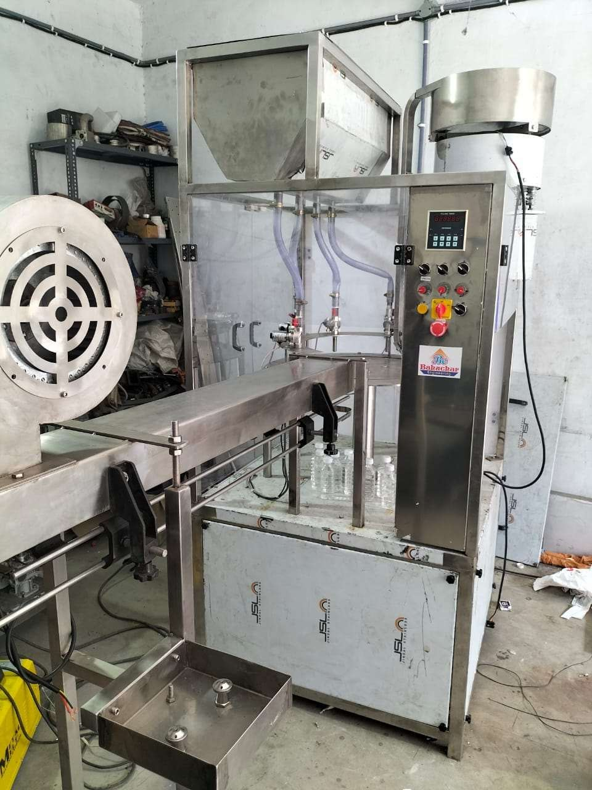

Salient Features

- ± 1 % Filling accuracy on single dose.
- No Bottle No Filling System.
- Rigid vibration free construction for trouble free performance.
- SS Elegantly matt finished body.
- Elegant and easy control panel for total control on operation.
- Minimum charge overtime, from one size to another container or fill size.
- Self-lubricating UHMW-PE guide profile.
- Error code display on A/C frequency drive on control panel.
- Drain tray around machine platform.
- Pneumatic bottle stopping arrangement.
- Synchronized One nos. A/c drives for main motor
- Safety guard , motor and pneumatic cylinders.
- MCB for over load protection, and prevent against short circuit.
- Inbuilt protection against over current, voltage fluctuation, short circuit in A/c frequency drive.

Technical Specification

Model |  |  | BESODA FILLING 20 TO 25 BPM -01
Output/Hour* |  |  | 1200 Bottle /200 Ml
Direction of Movement |  |  | Left to Right
Number of head/Syringe |  |  | 2 Nos Soda Head 1 Nos Syrup
Fill Size*** |  |  | 5 ml to 2000 ml
Electric Specification** | Main Machine |  | 1HP / 415Volts / 50 Hz.
 | Conveyor |  | . 4 Fit Air Conveyor, 10 Fit SS Belt Flat Conveyor
Height of Conveyor** |  |  | Adjustable
Sticker tunnel |  |  | Height Of Tunnel 500MM, Longest 800 MM
Inspection Light |  |  | 500x350 mm
Machine Dimensions** |  |  | 1000 mm (L) x 1000 mm (W) x 1650 mm (H)
Case Dimensions |  |  | 1200 mm (L) x 1200 mm (W) x 1800 mm (H)
Net Weight |  |  | 350 Kegs’.
Gross Weight |  |  | 450 Kegs.
Change parts required
Input Specifications
Container Neck Diameter** |  |  | Minimum 22 mm***
Container Size** | Round Shape |  | Ø 28 mm to Ø 100 mm  Respectively height 58 mm to 240 mm  (Height option for other bottle height available)
 | Flat / Square |  | 15mm to 100 mm (Length) Respectively 10mm to 50 mm (Width)  Respectively height 58 mm x 240 mm  (Height option for other bottle height available)
* Depends on Container size, fill size, Neck diameter of container, and nature of liquid etc.
** We can supply as per customer requirements.
*** With help of change parts.
Utility Requirement
Electrical supply |  | 3 Phase + Neutral + Earthing
Electrical load |  | 3 KW
Air Pressure: Minimum |  | 6 bar pressure 0.5 CFM

- SODA CARBONATION MACHINE (BE SODA CARBONATION MACHINE 01)

Description
With the aid of our skillful and deft workforce, we are able to offer our customers a wide range of Soda Carbonation Machine. These products are highly recommended and acknowledged amid our clients due to their usage in assorted industrial purposes. More to this, these products are well examined before getting dispatched at the end of our treasured patrons.

Operation

Salient Features

Capacity | 300 To 500 LITRE/ Hour
Driven Type | AUTO
Frequency | 50Hz
Material Grade | JSW SS304 STEEL
Phase | SINGLE PHASE

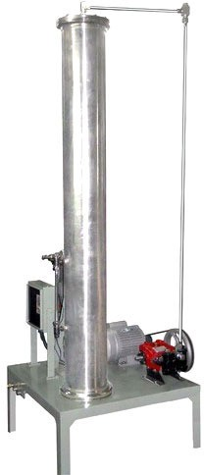

Utility Requirement

Electrical supply | 1 Phase + Neutral + Earthlings
Electrical load | 0.75 KW

Technical Specifications
Model |  | BE SODA CARBONATION 01
Output/Hour* |  | 1000 to 3000 Liter/ Hour
Automatic Grade |  | . Automatic
Construction |  | Stainless Steel
Electrical Specification** | Main Motor | 3 HP / 415 Volts / 50 Hz.
 | Pump | 3 Piston Pump
Height of Carbonation |  | 1500 MM
Machine Dimensions** |  | 500 mm (L) x 500 mm (W) x 2000 (H) Approx.
Case Dimensions |  | 750 mm (L) x 750 mm (W) x 2250 (H) Approx.

Net Weight |  | 100 Kegs Approx.
Gross Weight |  | 150 Kegs Approx.
Change parts required
Input Specifications
 | Diameter**
 | Height**
Container Size** | Round Shape | Ø 200 mm ***  Respectively height 1500 mm to 2000 mm*** (Height option for other bottle height available)
 | Flat / Square | 500mm to 500 mm (Length)*** Respectively 10mm to 50 mm (Width)*** Respectively height 58 mm X 240 mm***  (Height option for other bottle height available)

- TERMS AND CONDITIONS

1 | Price bases | All prices given in this offer are net and Ex-works Ahmedabad otherwise stated
2 | Delivery | Within 3-5 Week from the date of receipt of technically & commercially clear order along with advance payment or receipt of approval for input dimensions, whichever is later?
3 | Excise Duty | NIL
4 | Sales Tax | 18 % GST.
5 | Octroi | Octroi or any other incidental expenses are to be borne by the consignee.
6 | Packing & Forwarding | □ Packing charges as Actual.
 |  | □ Transportation is to be borne by the consignee.
□ Goods will be forwarded in the normal course and according to our usual practice in the absence of specific instructions with
regard to packing or transporter.
□ Our responsibility ceases once the goods are delivered on the
board carrier.
7 | Insurance | Transit Insurance against theft, pilferage, breakage, etc. will be arranged at extra cost at your explicit instruction, otherwise it will be assumed that goods are to be sent at your risk. Cost of such  insurance will be as actual to be borne by the consignee.
8 | Payment | □ 50 % advance along with purchase order and balance 50 % against Performa Invoice before dispatch. All payments are to be  secured by Demand Draft favoring M/S TORQ PACKAGING SOLUTION, payable at Ahmadabad.
 |  | □ Interest will be charged from the due date of invoice at the rate of 24 % p.a. on amount remaining unpaid after the due date.
□ In case of documents negotiated through bank for collection, all bank handling and incidental charges shall be borne by the purchaser. Refusal to honor the documents for whatsoever
reason shall be entirely at the purchaser's own risk and to Cost and Consequences.
 |  | □ Ownership of the goods shall remain with us until the full invoice value of the goods is received by us.
9 | Commissioning | □ For supervising and commissioning of the machine we will depute one of our engineers on free bases. Customer will have to send a prior intimation of readiness of electrical and  utility connections along with required materials.
10 | Order modification or cancellation: | □ The purchaser shall not be entitled to cancel or modify the Purchase Order except by our written consent.
□ Acceptance of any change in the order shall be at our sole discretion and we shall not be liable to give reasons for
nonacceptance.
11 | Warranty | Our goods carry a warranty of one-year trouble free operation from the date of dispatch. The warranty is only against manufacturing defect. It does not cover any electrical, electronic or bought out components. Components getting normal wear and tear would be  replaced at your cost.

12 | Note | Customer have to provide samples of bottles, caps, labels etc. along with the purchase order otherwise machine will be made as per our standard specifications, wherein we will take trial with water, caps, bottle, label etc available with us, which will be  acceptable to you.
13 | Jurisdiction | No legal proceedings shall be taken to enforce claims and no suit  arising out of any contracts shall be instituted except in a court of competent jurisdiction located within Ahmadabad, Gujarat.

